

|  |  |
| --- | --- |
| Date | 10 March 2025 |
| Team ID | 1.15 |
| Project Name | Exploring Cyber Security Understanding Threats and Solution in the Digital Age |
| Maximum Marks | 8 Marks |

**List of teammates–**

|  |  |  |  |
| --- | --- | --- | --- |
| **S.no** | **name** | **collage** | **contact** |
| 1 | Priti Shivaji Chavan-Patil | D.Y.Patil Agriculture and Technical University Talsande | 7276029080 |
| 2 | PratibhaMahadevChavan | D.Y.Patil Agriculture and Technical University Talsande | 8767651712 |
| 3 | Rajani Jayraj Salunkhe | D.Y.Patil Agriculture and Technical University Talsande | 9322461040 |
| 4 | AnujaBhikajiChavan | DYP Agriculture and Technical University Talsande | 8767348641 |

**Abstract:**

In the digital age, cybersecurity has become a critical concern as cyber threats continue to evolve in complexity and scale. This paper explores the landscape of cybersecurity, identifying key threats such as malware, phishing, ransomware, insider threats, and advanced persistent threats (APTs). It examines the vulnerabilities that cybercriminals exploit, including weak authentication, software flaws, and human error.

The study also highlights modern security solutions and strategies, including encryption, multi-factor authentication, artificial intelligence-driven threat detection, and zero-trust architecture. Additionally, it discusses the role of cybersecurity frameworks, regulations, and best practices in mitigating risks.

**Scope of the Project :**

**1. Cyber Threat Landscape**

Identification of common cyber threats such as malware, ransomware, phishing, denial-of-service (DoS) attacks, and insider threats.

Analysis of advanced persistent threats (APTs) and nation-state cyberattacks.

Examination of social engineering tactics and human vulnerabilities.

**2. Vulnerabilities in Digital Systems**

Common weaknesses in software, hardware, and networks.

Human factors and the role of social engineering in cybersecurity breaches.

Case studies of real-world cyber incidents and data breaches.

**3. Cybersecurity Solutions and Defense Mechanisms**

Implementation of security best practices, including encryption, multi-factor authentication (MFA), and firewalls.

Role of artificial intelligence (AI) and machine learning (ML) in threat detection and prevention.

Overview of zero-trust architecture and its effectiveness in modern cybersecurity.

**4. Regulatory and Legal Frameworks**

Exploration of global cybersecurity laws and regulations, such as GDPR, CCPA, and NIST frameworks.

Compliance requirements for businesses and organizations.Ethical considerations in cybersecurity practices.

**5. Emerging Trends and Future Prospects**

The impact of quantum computing on cryptography and data security.

The rise of blockchain technology for secure transactions and identity management.

Predictions for the future of cybersecurity in an increasingly digital world.

**Objectives of the Project:**

**1. Understanding Cyber Threats**

Identify and classify different types of cyber threats such as malware, phishing, ransomware, and insider threats.

**2. Assessing Security Vulnerabilities**

Examine common security weaknesses in software, networks, and human behavior. Study real-world cyberattacks and breaches to understand their impact and causes.

**3. Exploring Cybersecurity Solutions**

Investigate modern defense mechanisms such as encryption, firewalls, intrusion detection systems, and multi-factor authentication.

**4. Examining Legal and Ethical Aspects**

Review global cybersecurity regulations, including GDPR, CCPA, and NIST frameworks.Discuss ethical considerations in cybersecurity practices and data protection.

**5. Identifying Emerging Trends**

Explore the future of cybersecurity with advancements in AI, blockchain, and quantum computing.

**6. Providing Recommendations**

Suggest best practices for individuals and organizations to strengthen their cybersecurity posture.

**Step 1:Various Ideas**

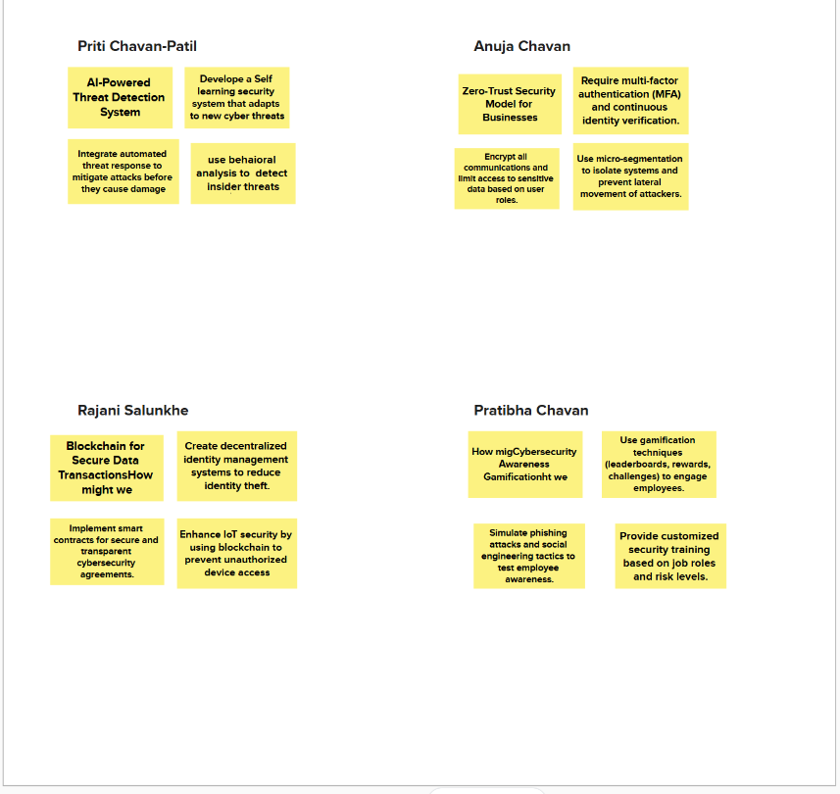

**Step2:Selecting some features and grouping them**

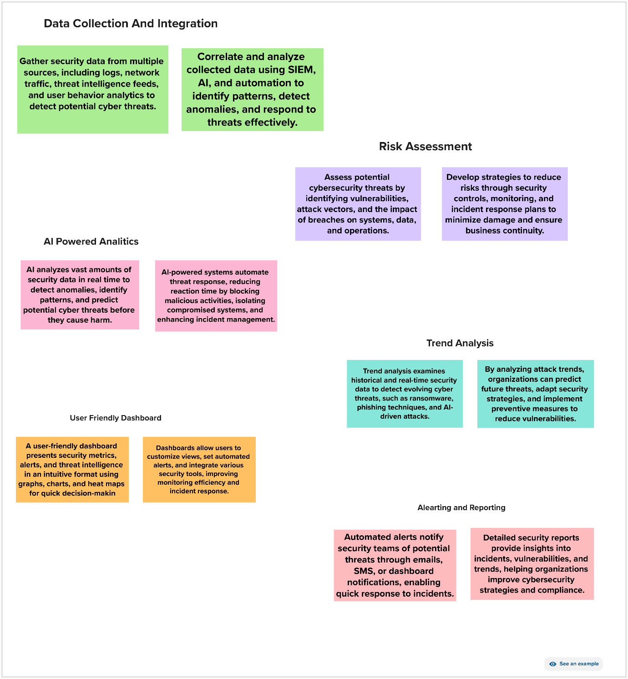

**Step 3:Priority Chart**

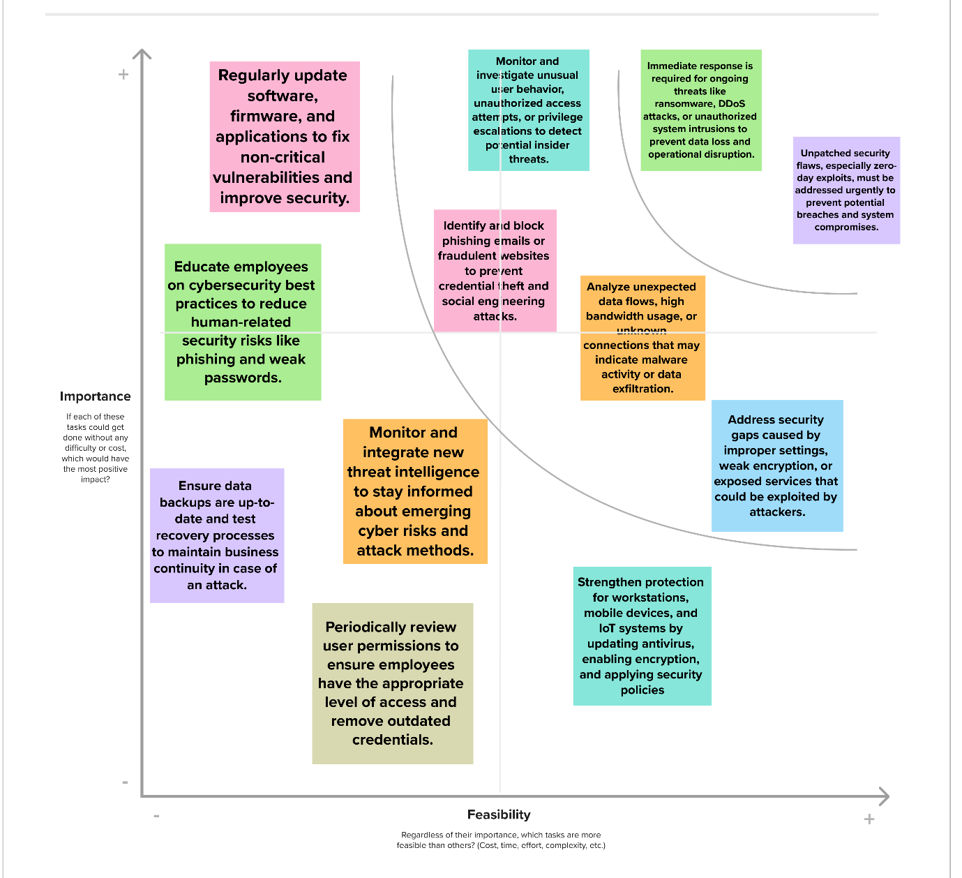

**Step 4:Empthy Map**

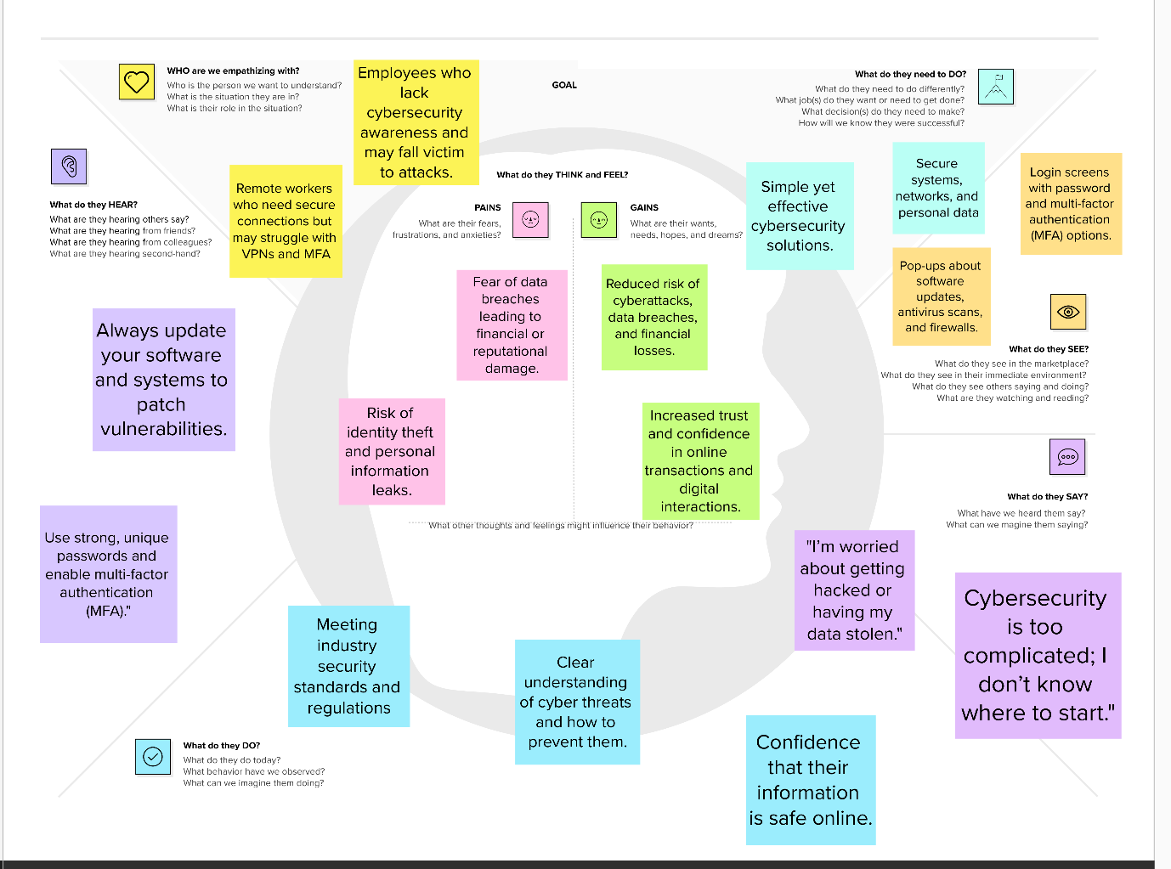

**Problem Statement:**

The cybersecurity landscape is continuously evolving, with new and sophisticated threats emerging across various industries. Organizations often struggle to keep pace with these evolving threats due to a lack of real-time intelligence, proactive defense mechanisms, and an understanding of adversary tactics. Traditional security strategies rely on reactive measures, leaving critical systems and data vulnerable to cyberattacks. This project aims to analyze the latest cyber threats, assess risk factors, and develop comprehensive defensive strategies using threat intelligence, risk management frameworks, and proactive security measures. By leveraging data-driven insights, organizations can strengthen their security posture and mitigate potential cyber risks effectively.